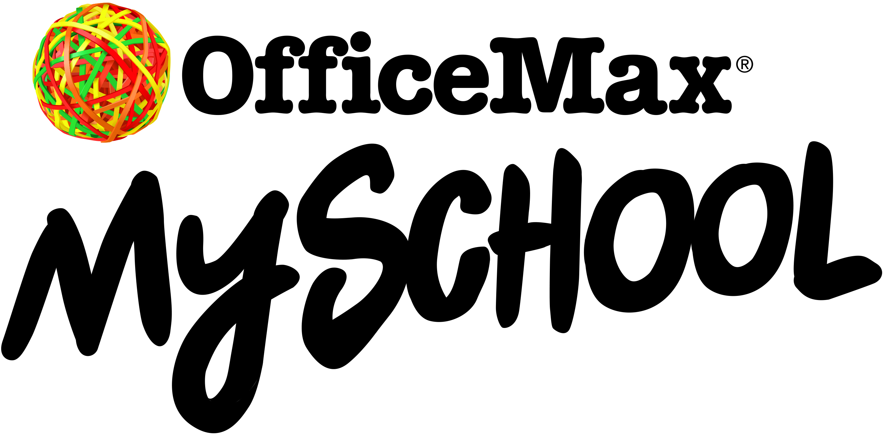

7th December 2022

Dear Parent / Guardian,

Get back to school stationery ready!

We know getting ready for the first day back at school can be a challenge for parents and kids. That’s why we’ve teamed up with OfficeMax to make your back to school shop super easy. And if you order in December, you’ll go in the draw to WIN 1 of 5 $1000 cash prizes — plus, you’ll get a FREE A4 Magnetic Whiteboard Family Organiser*.

Your child’s class list is already loaded. Just go to myschool.co.nz. Simply add your details, check that you want everything on the list, then click and confirm — and OfficeMax will get your delivery underway.

Order in December and choose to receive your order straight away or in January.

Laybuy* is also available, so you can pay in 6 weekly, interest-free payments and still get your order right away.

We encourage you to order early to ensure your child has all their stationery requirements ready to go in plenty of time for the start of Term 1.

So go ahead and beat the back to school rush, order today and give them the best start possible.

OfficeMax makes it easy to get back to school ready with these great benefits

- Free delivery on orders over $60*

- Pay now or in easy instalments — internet banking, credit cards, debit cards or pay in 6 weekly, interest-free payments with Laybuy*

- School Rewards — when you shop on myschool.co.nz we earn rewards* that can be used to purchase extra resources for school

- Price match promise — shop with confidence, if you find a lower price OfficeMax will match it*

- Beat the back to school rush — avoid queues and busy shopping malls by shopping online from the safety and comfort of your home

* Terms & Conditions apply, see myschool.co.nz for details.

Please don’t hesitate to contact the office if you have any queries about OfficeMax MySchool. We look forward to your child having a successful start to the new school year!

Have a safe and restful holiday.

Kind regards,

Sarah Hynds
Principal
Karaka School

